<https://www.overleaf.com/8385691655qkswzbkhtdgx#28434e>

1. Fix the images, make them all separate figures 6-8
2. Fix percentages. 2 decimal places - done
3. Put values in where necessary in M&M - done

**ABSTRACT**

ASD (Autism Spectrum Disorder) affects children globally, with its prevalence on the rise. Early detection is crucial for educating children .In this study,we explore ML potential in identifying effective teaching methods for children with ASD.We collected dataset from different sources related to ADS disorder ,making sure its uniformity.It consist of behavioral and individual characteristics ,further categorized into 7 different different teaching method. We have used ML 4 algorithms: K-Nearest Neighbors, MLP, Random Forest, and Decision Tree, to train and predict suitable training methods. We discovered that 2 algorithms were the best predictors of the most suitable teaching method for a young child with ASD: MLP and Decision Tree. Our findings suggest that Machine Learning Algorithms can help create teaching plans tailored specifically for children with ASD in a way that can completely transform and enhance the learning experience. It can address barriers and provide equitable healthcare solutions, for low-income communities that lack the resources to provide proper care for affected children.

**INTRODUCTION**

1]

Shahad Sabbar Joudar, Ahmed Shihab Albahri, and Rula A Hamid. Triage

and priority-based healthcare diagnosis using artificial intelligence for

autism spectrum disorder and gene contribution: a systematic review.

Computers in Biology and Medicine

, 146:105553, 2022.

[2]

Matthew J Maenner.

Prevalence of autism spectrum disorder among

children aged 8 years—autism and developmental disabilities monitoring

network, 11 sites, united states, 2016.

MMWR. Surveillance Summaries

,

69, 2020.

[3]

Sharmila Banerjee Mukherjee. Autism spectrum disorders—diagnosis and

management.

The Indian Journal of Pediatrics

, 84(4):307–314, 2017.

[4]

Sally Lindsay, Meghann Proulx, Nicole Thomson, and Helen Scott. Edu-

cators’ challenges of including children with autism spectrum disorder in

mainstream classrooms.

International Journal of Disability, Development

and Education

, 60(4):347–362, 2013.

(-)Chaddad, Ahmad, Jiali Li, Qizong Lu, Yujie Li, Idowu Paul Okuwobi, Camel Tanougast, Christian Desrosiers, and Tamim Niazi. 2021. "Can Autism Be Diagnosed with Artificial Intelligence? A Narrative Review" *Diagnostics* 11, no. 11: 2032. https://doi.org/10.3390/diagnostics11112032

(-)Russell, G., Stapley, S., Newlove-Delgado, T., Salmon, A., White, R., Warren, F., Pearson, A. and Ford, T. (2022), Time trends in autism treatments over 20 years: a UK population-based cohort study. J Child Psychol Psychiatr, 63: 674-682. <https://doi.org/10.1111/jcpp.13505>

(-)Kasari, C., Gulsrud, A., Freeman, S., Paparella, T., Hellemann, G. (2020). Longitudinal follow-up of children with autism receiving targeted interventions on joint attention and play. Journal of the American Academy of Child & Adolescent Psychiatry, 59(3), 452-461.

Introduction

* What is my work
* Works done in past in reference to my work

Autism Spectrum Disorder (ASD) is a neurodevelopmental condition with lifelong effects and differing severity across a spectrum (1).

Data from 2020 suggests that roughly 1 in 36 children receive a diagnosis of Autism Spectrum Disorder (ASD), marking a significant uptick of approximately 20 percent from 2018, when the diagnosis rate was reported as 1 in 44

(2). Despite its common occurrence, the precise cause of autism remains unidentified, and there exists no definitive cure. Timely detection is pivotal in managing ASD, facilitating prompt initiation of interventions like behavioral therapies and educational approaches, which can greatly enhance outcomes (3). Education for children with ASD remains a challenge, as they often require specialized support and resources(4). Despite progress in research and diagnosis, the educational system continues to face challenges in meeting the needs of students with ASD, resulting in problems like school dropout rates and subpar academic performance.

ASD showcases extensive variability, with each person displaying distinct characteristics. Consequently, educational strategies that prove effective for one individual may not be ideal for another. This poses a challenge in determining the most suitable teaching method for each child. The diversity inherent in Autism Spectrum Disorder (ASD), as suggested by its name, necessitates a comprehensive approach to discerning the individual requirements of each child.

Through the utilization of machine learning algorithms, we can enhance the precision of identifying the educational requirements of children diagnosed with ASD. This, in turn, enables the implementation of more efficient and inclusive educational strategies.

Various interventions are available for different subtypes of autism, with the effectiveness of these interventions depending on the specific characteristics of each child with autism spectrum disorder (ASD).

In the 1970s, a method called evidence-based practice began. It's about using scientific proof to make sure that programs for children with autism really help them. This method has shown that there are two main types of programs:

One is called comprehensive treatment models (CTMs). These programs try to help with many different parts of a child's development.The other is focused intervention practices. These programs concentrate on teaching specific skills or achieving particular goals to help children with autism.The aim is to apply these evidence-based practices (EBPs) to develop personalized education or intervention plans. These plans can then be consistently used in early intervention and school-based programs. This helps improve outcomes for students with autism.

Different methods of intervention have been studied in books and articles to meet various needs of people with autism. Antecedent-based interventions, such as using visual cues to indicate appropriate times for behavior, have shown effectiveness in reducing stereotypic behaviors in educational settings. Research on Technology-Aided Instruction and Intervention (TAII) has recognized computer-assisted instruction as an evidence-based practice. However, it's important to note that not all technology-based interventions have been found to be effective. Task Analysis has proven effective in training teachers for inquiry-based science instruction aimed at students with intellectual disabilities. This highlights a direct link between training and teaching capability. Pivotal Response Training (PRT) has shown effectiveness in enhancing complex social behaviors, language skills, and joint attention in children with autism. Moreover, these positive changes have been observed to persist over time. Peer-mediated strategies, which leverage socially competent peers to model and reinforce appropriate behavior, have significantly improved social interactions by altering peer expectations and promoting peer effort.The Picture Exchange Communication System (PECS) has been discovered to significantly improve social-communicative skills, particularly in adaptive behavior and unstructured environments. This makes it a valuable resource for non-verbal children with autism.

Autism screening typically involves administering a questionnaire designed to identify behavioral traits and certain individual characteristics, which are then used to generate a score indicative of the likelihood of autism.

Recent studies aimed to simplify and enhance the screening process for autism spectrum disorder (ASD) in toddlers. By employing a neural network approach on data from nearly 15,000 toddlers, researchers achieved a high accuracy rate of 99.72% in identifying ASD using only 18 questions from the M-CHAT-R, a commonly used screening tool. This accuracy was consistent across various demographic groups. The findings suggest that this method could streamline ASD screening, eliminating the need for laborious follow-up procedures and reducing human error, potentially leading to earlier diagnosis and intervention for affected children [16].

.

Another research employed logistic regression in a novel ML framework for ASD screening in adults and adolescents, identifying key features for autism screening through information gain (IG) and Chi square testing [17].

Another study used AI and ML to develop a mobile app for predicting Autism Spectrum Disorder (ASD) early. By merging techniques like Random Forest-CART and Random Forest-Id3, the app shows improved accuracy and efficiency compared to current methods. It offers a promising solution for accessible ASD prediction across all age groups[18].

Additionally a study aimed at using ML to create a cost effective,quick and user friendly autism screening tool. Two algorithms are trained—one based on parent questionnaires and another on analyzing children's behavior in home videos. These are combined for higher accuracy. Novel techniques are used to handle limited data. A clinical study with 162 children shows significant improvement over standard tools in accuracy. The findings suggest ML is reliable for autism detection outside clinical settings, though further studies are needed for validation and improvement [19].

Dr. Fadi Fayez Thabtah from Manukau Institute of Technology, New Zealand, published a dataset containing responses, scores, and suitable interventions for different autism types [20].

Autistic children have diverse needs in education. Machine learning can help identify tailored teaching methods based on individual characteristics like behavior and communication, improving their learning experience[21].

In this study, we propose using Machine Learning’s unique capabilities to create an AI capable of identifying the proper teaching methods for a child with ASD.

There are 7 distinct educational methods that we will take into consideration:Technology-aided instruction utilizes technology to allow children to learn at their own pace, providing extra time when needed; Antecedent based intervention identifies and eliminates factors that disrupt learning; Pivotal response training boosts motivation, communication, and self-monitoring skills; Peer-mediated instruction involves peers in teaching and social skill development; Picture Exchange Communication utilizes visual symbols for communication; Task Analysis breaks down tasks into smaller steps for easier comprehension and completion, particularly beneficial for those who struggle with tasks, and finally we also consider situations where a child does not need specialized education. This AI will use extensive datasets to train and test in order to become an expert analyst of the needs of an autistic individual. After evaluating datasets and making a uniform constructed dataset, we split it into a train and test set. We then employed four algorithms (KNN, Decision Tree, Random Forest and MLP) to find the most efficient one. There were two algorithms which worked best, (the MLP and random forest algorithms), and which are most suitable for teaching methods for childrens with ASD.

Our study showcases Machine Learning's potential in tailoring educational interventions for individuals with Autism Spectrum Disorder. This approach promises personalized support, enhancing their learning experiences. Further real-world validation is needed to optimize its effectiveness.

**Data Analysis**

We conducted a comprehensive data analysis for the purpose of creating a uniform dataset that could be used to train and test the AI. After collecting 4 datasets from reputable sources, they were morphed to fit standards. Prior to analysis, we conducted thorough data cleaning procedures to ensure data quality and consistency. We identified and handled missing values, outliers, and anomalies. Data types were standardized, and inconsistencies in formatting were resolved across all datasets. After individual datasets were cleaned and preprocessed, they were integrated into a unified dataset.

**Materials:**

The development of this AI required the utilization of many different tools. For this project, we used Google Colab to write code in Python. We also worked with different datasets that contain information relevant to finding the correct teaching method for a child with ASD. To analyze the data and build the AI model, we relied on Python packages including pandas for managing data, seaborn and Matplotlib for visualizing data, scikit-learn for machine learning tasks, pickle for storing models, and SciPy for scientific computations. These tools helped us efficiently develop and evaluate the AI system.

**Methods:**

In this section, we explain how we conducted our experiments. We give a thorough explanation of the dataset we used, including how the different categories are distributed and the techniques we used to prepare the data, in the dataset subsection. Then, we describe the steps we took in our experimental approach in the following subsection on methodology.

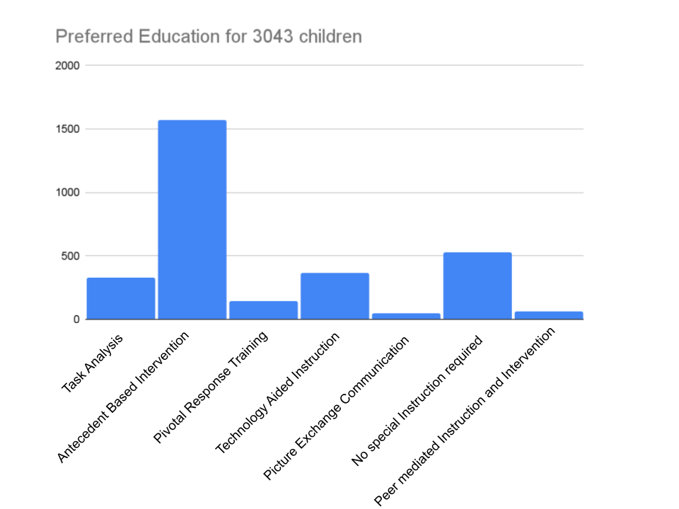

**Data**

The dataset contains a total of 3043 samples with 17 features. Among these features, 10 describe behaviors, while 7 are related to individual characteristics.

The target variable is categorized into seven different classes, with the distribution as shown in Figure 1.1. The category with the smallest number of samples is Picture Exchange Communication, whereas Antecedent Based Intervention has the most. To prepare the data, missing values were filled in, and feature scaling was done for normalization. The dataset was divided into training and testing sets using an 80-20 ratio. It's worth mentioning that we didn't adjust for any data skewness before running the experiments.

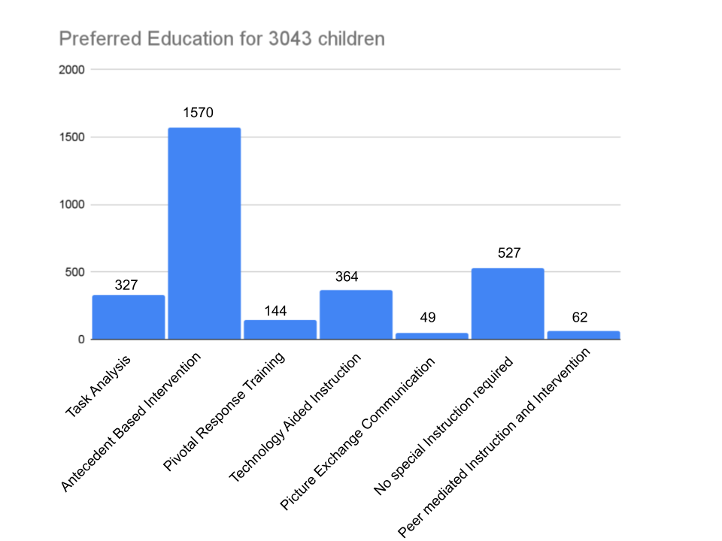

**Procedures**

Four algorithms KNN, Decision Tree, Random Forest and MLP were used to conduct experiments. Five fold cross-validation was used to determine the predictive performance of each algorithm. For Random Forest, the hyper-parameter number of trees was tuned between 10 to 100, while the depth varied between 1 and 7.For KNN, the hyper-parameter number of points K was tuned between 1 to 20. For MLP, the hyper-parameter LR was tuned between 0.000001 to 0.05, while the Epochs varied between 10 and 50. For Decision Tree, the hyper-parameter max depth was tuned between 1 to 7. Following training, the model's predictions on the validation set were gathered and compared to the actual labels. Accuracy and confusion matrices were computed for each fold to assess the model's performance. Ultimately, accuracy scores from all folds were reported along with their average to gauge the model's overall performance during training.We preserved the best model in each instance and assessed their performance on the test dataset, providing a detailed report of these results as well.

**MATERIALS AND METHODS (250)** -

* What software hardware
* What procedure

Developing this AI necessitated employing a variety of tools. We utilized Google Colab for coding in Python and worked with diverse datasets relevant to identifying the most effective teaching method for children with ASD. To analyze the data and construct the AI model, we leaned on Python libraries including pandas for data management, seaborn and Matplotlib for visualization, scikit-learn for machine learning tasks, pickle for model storage, and SciPy for scientific computations. These tools streamlined the development and evaluation of our AI system.

To forge this AI model geared towards pinpointing the optimal teaching approach for children with Autism Spectrum Disorder (ASD), we used a systematic approach. Initially, a comprehensive data analysis was conducted to establish a standardized dataset suitable for training and testing the AI. Four reputable datasets were collected and harmonized to meet uniform standards. Thorough data cleaning procedures were executed to ensure data integrity and consistency, encompassing the handling of missing values, outliers, and anomalies. After that step, data types were standardized, and formatting inconsistencies were rectified across all datasets.

After individually cleaning and preprocessing each dataset, they were seamlessly integrated into a cohesive dataset, allowing for a seamless analysis of the combined data. Subsequently, the unified dataset was partitioned into two subsets: a training dataset and a test dataset. This enables model training on one dataset while validating performance on another unseen dataset.

For model training, four distinct machine learning algorithms were employed: K-Nearest Neighbors (KNN), Decision Tree, Random Forest, and Multi-Layer Perceptron (MLP). Each algorithm underwent training on the training dataset to discern patterns and relationships between input features and the target variable—here, the most efficacious teaching method for children with ASD.

Post-training, the performance of each algorithm was evaluated by plotting graphs to visualize accuracy scores. Subsequently, the most proficient model among the four algorithms was selected based on accuracy and suitability for the task.

This evaluative step ensured the chosen model would offer reliable and precise recommendations for educators and caregivers interacting with children with ASD.

The development of this AI required the utilization of many different tools. For this project, we used Google Colab to write code in Python. We also worked with different datasets that contained information relevant to finding the correct teaching method for a child with ASD. To analyze the data and build the AI model, we relied on Python packages including pandas for managing data, seaborn and Matplotlib for visualizing data, scikit-learn for machine learning tasks, pickle for storing models, and SciPy for scientific computations. These tools helped us efficiently develop and evaluate the AI system.

To create an AI model aimed at identifying the most suitable teaching method for children with Autism Spectrum Disorder (ASD), a systematic process was undertaken. Firstly, multiple datasets pertaining to ASD and educational methodologies were gathered. Since these datasets varied in format and structure, adjustments were made to ensure uniformity across all datasets. This step was crucial for seamless integration and analysis of the combined data. Subsequently, the unified dataset underwent division into two subsets: a training dataset and a test dataset. This division is fundamental in machine learning as it allows for model training on one set of data while validating its performance on another, unseen set. For model training, four different machine learning algorithms were employed: K-Nearest Neighbors (KNN), Decision Tree, Random Forest, and Multi-Layer Perceptron (MLP). Each algorithm was trained on the training dataset to identify patterns and relationships between the input features and the target variable, which in this case, would be the most effective teaching method for children with ASD. Following model training, the performance of each algorithm was assessed by plotting graphs to visualize their accuracy scores. These visualizations provided insights into the efficacy of each algorithm in predicting the optimal teaching method. Finally, the best-performing model out of the four algorithms was selected based on its accuracy and suitability for the task at hand. This evaluation step ensured that the chosen model would provide reliable and accurate recommendations for educators and caregivers working with children with ASD, ultimately contributing to improved learning outcomes for this population.

**Discussion:**

The results of validating the Hyperparameter Tuning (HPT), for algorithms show various trends in their performance.

In case of Multilayer Perceptron (MLP) we notice fluctuations in accuracy based on combinations of learning rates (LR) and epochs. A key point to highlight is that the highest accuracy reaching 99.296875% is achieved with a learning rate of 0.05 and 50 epochs. On the contrary performance decreases notably at epoch 10 where accuracy drops to 97.81% though still respectable. It's important to mention that this accuracy is lower compared to what's achieved with other epoch values. Additionally when the learning rate (LR) is set to 0.005 there is an improvement in accuracy as the number of epochs increases. Interestingly LR values of 0.01 and 0.05 maintain accuracies throughout epoch values indicating a possible convergence, at these LR levels.

In the case of Random Forest, it's important to highlight that the best accuracy, reaching 94.92187%, is achieved when we set the number of trees to 50 and the maximum depth to 7. Looking at the graph, it's clear that increasing the maximum depth tends to improve the accuracy score, especially when we increase the number of trees up to 50. However, if we continue to increase the number of trees beyond 50, the accuracy starts to decrease. This indicates a delicate balance between the number of trees and maximum depth to achieve the highest accuracy.

When we looked into the performance of the decision tree algorithm , the only hyper parameter was maximum. We tested different values for this, ranging from 1 to 7. And when we plotted the results on a graph, we saw a pattern: as we increased the maximum depth, the accuracy of the algorithm also went up. What really caught our attention was that the accuracy reached its highest point, a remarkable 94.37\%, when we set the maximum depth to 7. While not optimal, this accuracy is still commendable.

Finally,let's talk about the k-nearest neighbors algorithm. This algorithm looks at the 'k' closest neighbors to make predictions. We tried different values of 'k', ranging from 1 to 20, to see how it affected the accuracy. Interestingly, we found that the best accuracy, reaching 80.62\%, was obtained when 'k' was set to 9. Although the accuracy didn't change much with other 'k' values, it's worth noting that odd values of 'k' seemed to work better for the algorithm.

* **Results(250)**

During the training phase, the MLP algorithm showcased exceptional performance with an accuracy of 99.3%, indicating its robust ability to understand and learn from the provided datasets. Following closely behind was the random forest algorithm, which achieved an accuracy of 94.9%, demonstrating its capability to discern patterns and make informed decisions. The decision tree algorithm also performed commendably with an accuracy of 94.4%, showcasing its efficacy in handling complex datasets. However, the KNN algorithm exhibited a slightly lower accuracy of 80.6%, suggesting some limitations in its ability to generalize patterns effectively.

Subsequently, the model was put to the test with a separate set of data to evaluate its real-world applicability. Impressively, the MLP algorithm maintained its exceptional accuracy of 100%, affirming its reliability in identifying suitable teaching methods for autistic individuals. The decision tree algorithm also performed admirably during testing, achieving an accuracy of 96.9%, reaffirming its efficacy in practical scenarios. Similarly, the random forest algorithm demonstrated consistent performance with an accuracy of 95%, indicating its robustness in real-world applications. However, the KNN algorithm showed a slight increase in accuracy during testing, reaching 81.6%, albeit still lower compared to other algorithms

**Future suggestion:**

In the future, it would be valuable to conduct studies that follow the progress and effectiveness of the teaching methods identified over time. By tracking how well these methods work for children with ASD over an extended period, we can better understand how to adapt and improve them as needs change.

Another important area for future research is creating personalized learning plans based on the predictions made by machine learning. These plans would take into account each child's unique strengths, challenges, and preferences, ensuring that their educational experience is tailored to their individual needs.

Additionally, integrating feedback from educators, parents, and caregivers into the machine learning models could further refine the teaching recommendations. By continuously updating and improving these recommendations based on real-time data and input, we can ensure that they remain relevant and effective for children with ASD.

**Limitations**

In our study, we looked into how machine learning can help figure out the best ways to teach kids with Autism Spectrum Disorder (ASD). But it's important to keep in mind that every kid with ASD is different, so what works for one might not work for another. Also, the data we used came from different sources about ASD, but it might not cover all the different experiences and needs of kids with ASD. We focused on a few specific machine learning methods, but there are lots of other ones out there that might work too. And even though we mainly looked at accuracy to see how well our methods worked, there are other things to consider too, like how precise they are. Finally, while our study shows some promise, actually using these methods in real classrooms could be tricky because of things like limited resources and making sure teachers have the right training and support. So, while our study gives us some good ideas, we have to be careful about how we use them in the real world.

**-Conclusion(250 words).**

* Implications of the work
  + Could help low income communities with low access to expensive diagnostic tools
* Why it matters
  + Autism cases are rising
  + \
* Why AI
  + Efficient

In wrapping up, our study emphasizes the importance of personalized education for children with Autism Spectrum Disorder (ASD), recognizing their unique needs and challenges. With ASD becoming more prevalent, there's a pressing need for effective educational strategies tailored to each child's requirements. Through the use of Machine Learning (ML) algorithms, we've shown that it's possible to identify the best teaching methods for children with ASD.

Our research highlights the promising accuracy of ML algorithms like the Multi-Layer Perceptron (MLP), Decision Tree, and Random Forest in predicting suitable educational interventions for children with ASD. These algorithms offer hope for transforming the educational journey of children with ASD by providing personalized support and improving learning outcomes.We can overcome barriers to access and provide equitable healthcare solutions for low-income communities.

By harnessing ML techniques, we can bridge the gap between research and practice, ensuring that educational interventions are grounded in solid evidence and tailored to individual needs.

Looking ahead, it's crucial to validate and refine our AI model through real-world applications and further research. Collaboration among researchers, educators, and healthcare professionals will be vital in successfully implementing ML-based educational interventions for individuals with ASD.

In summary, our study adds to the growing evidence supporting the effectiveness of ML in enhancing educational outcomes and quality of life for individuals with ASD. This paves the way for more inclusive and effective educational practices, ultimately helping children with ASD reach their full potential.

Dataset:

The dataset, a comprehensive collection of information, encompasses a total of 3043 samples, each meticulously curated and categorized. In this big dataset, there are 17 different features, and each one gives us a special view into what's going on underneath. Out of these features, 10 focus on understanding how people behave, digging deep into the details of their actions and reactions, while the other 7 features help us understand what makes each person unique, revealing different aspects of their personality and traits..

The focal point of analysis within this dataset revolves around a target variable, thoughtfully classified into seven discrete classes, each representing a distinct category or outcome. This categorization scheme, explained in Figure 2, provides a visual representation of the distribution of samples across the various classes.

Interestingly, upon closer examination, it becomes apparent that the category "Picture Exchange Communication" boasts the smallest representation within the dataset, underscoring its relative rarity, whereas "Antecedent Based Intervention" emerges as the most prevalent category, commanding a substantial portion of the dataset.

In preparation for analysis, the dataset underwent meticulous preprocessing steps aimed at ensuring data integrity and reliability. This involved the imputation of missing values and the application of feature scaling techniques to facilitate normalization and comparability across features.

Furthermore, to facilitate robust model training and evaluation, the dataset was methodically partitioned into training and testing subsets, adhering to an 80-20 ratio. It is imperative to note that, in the interest of transparency and methodological rigor, no adjustments were made for data skewness prior to conducting the experiments, preserving the authenticity of the underlying data distribution.

The results of validating the Hyperparameter Tuning (HPT),

algorithms show various trends in their performance.

In case of Multilayer Perceptron (MLP) we notice fluctu-

ations in accuracy based on combinations of learning rates

(LR) and epochs. A key point to highlight is that the highest

accuracy reaching 99.3% is achieved with a learning rate of

0.05 and 50 epochs. On the contrary performance decreases

notably at epoch 10 where accuracy drops to 97.81% though

still respectable. It’s important to mention that this accuracy is

lower compared to what’s achieved with other epoch values.

Additionally when the learning rate (LR) is set to 0.005

there is an improvement in accuracy as the number of epochs

increases. Interestingly LR values of 0.01 and 0.05 maintain

accuracies throughout epoch values indicating a possible con-

vergence, at these LR levels.

In the case of Random Forest, it’s important to highlight

that the best accuracy, reaching 94.92%, is achieved when we

set the number of trees to 50 and the maximum depth to 7.

Looking at the graph, it’s clear that increasing the maximum

depth tends to improve the accuracy score, especially when we

increase the number of trees up to 50. However, if we continue

to increase the number of trees beyond 50, the accuracy starts

to decrease. This indicates a delicate balance between the

number of trees and maximum depth to achieve the highest

accuracy. n this study, we investigated the applicability of machine

learning techniques in identifying optimal teaching methodolo-

gies for children diagnosed with Autism Spectrum Disorder

(ASD). It is important to acknowledge the inherent hetero-

geneity within the ASD population, which calls for individ-

ualized approaches to education. While our analysis draws upon diverse datasets sourced from ASD-related literature, it

is important to recognize this data might not represent the

needs and experiences of all children with ASD. While our

study focused on a selection of machine learning algorithms,

there could very well be a vast landscape of other algorithms

that are also efficient. In addition even though our evaluation

metrics were primarily centered on accuracy, other criteria

such as precision could have been considered as well to

comprehensively assess the efficacy of our methods. Real-

world implementation of machine learning-driven educational

strategies presents notable challenges, including resource con-

straints along with teacher training and support. As such,

while our findings offer promising insights, their practical

application requires caution.

In the future, it would be valuable to conduct studies that

follow the progress and effectiveness of the teaching methods

identified over time. By tracking how well these methods work

for children with ASD over an extended period, we can better

understand how to adapt and improve them as needs change.

Another important area for future research is creating per-

sonalized learning plans based on the predictions made by

machine learning. These plans would take into account each

child’s unique strengths, challenges, and preferences, ensuring

that their educational experience is tailored to their individual

needs.

Additionally, integrating feedback from educators, parents,

and caregivers into the machine learning models could further

refine the teaching recommendations. By continuously updat-

ing and improving these recommendations based on real-time

data and input, we can ensure that they remain relevant and

effective for children with ASD.

Related Work Section

Several recent studies have demonstrated the potential of artificial intelligence (AI) in addressing various aspects of autism spectrum disorder (ASD), particularly in the realms of early detection, screening, and personalized educational interventions. Notably, advancements in neural network approaches have enabled high accuracy rates in early detection of ASD among toddlers using tools such as the Modified Checklist for Autism in Toddlers-Revised (M-CHAT-R). Additionally, innovative machine learning frameworks, such as logistic regression combined with feature selection techniques, have shown promise in ASD screening for both adolescents and adults. Mobile applications leveraging AI techniques, such as Random Forest combined with Classification and Regression Trees (CART) and Iterative Dichotomiser 3 (ID3), have emerged as efficient tools for early prediction of ASD across different age groups. Moreover, AI-driven algorithms have facilitated the development of cost-effective and user-friendly screening tools, integrating parent questionnaires and behavioral analysis from home videos to significantly enhance accuracy compared to conventional methods. Dr. Fadi Fayez Thabtah's work in curating datasets containing responses, scores, and suitable interventions for various types of autism has laid a solid foundation for AI-driven intervention planning. Furthermore, the integration of machine learning in identifying tailored teaching methods based on individual characteristics like behavior and communication has shown promise in improving learning experiences for autistic children. Our study contributes to this burgeoning field by proposing a machine learning-based approach to identify personalized teaching methods for children with ASD, with the aim of optimizing their educational outcomes and experiences.

In conclusion, our study underscores the supreme importance of personalized education for children diagnosed with Autism Spectrum Disorder (ASD), recognizing their unique needs and challenges. As the frequency of ASD continues to rise, there emerges a critical essential for the development and implementation of effective educational strategies finely tuned to address the specific requirements of each child. Through the strategic integration of Machine Learning (ML) algorithms into our research framework, we have not only showcased their potential but also demonstrated the feasibility of identifying optimal teaching methodologies tailored to the diverse needs of children with ASD.

Our research findings shed light on the remarkable accuracy and effectiveness of ML algorithms, including the Multi-Layer Perceptron (MLP), Decision Tree, and Random Forest, in predicting and recommending appropriate educational interventions for children with ASD. These algorithms hold immense promise in revolutionizing the educational path of children with ASD by offering tailored support and significantly enhancing learning outcomes. Moreover, they present a guiding light of hope in breaking down access barriers and delivering fair healthcare and educational solutions, particularly for underserved communities struggling with limited resources.

By harnessing the power of ML techniques, we not only bridge the gap between theoretical research and practical application but also ensure that educational interventions are firmly rooted in experiential evidence and meticulously tailored to individual needs.

Looking towards the future, it is essential to initiate on a journey of continuous validation and refinement of our AI model through rigorous real-world applications and further experiential research. Collaboration and synergy among multidisciplinary stakeholders, including researchers, educators, and healthcare professionals, will be instrumental in the successful implementation and scaling of ML-based educational interventions tailored specifically for individuals with ASD.

In summary, our study makes a significant contribution to the growing body of evidence supporting the transformative potential of ML in augmenting educational outcomes and enhancing the overall quality of life for individuals with ASD. This not only signals the dawn of a new era in more inclusive and effective educational practices but also serves as a signal of empowerment, propelling children with ASD towards the realization of their full potential and a brighter future.